Query languages for SSD and XML

Chapter 2 – querying part

Query languages

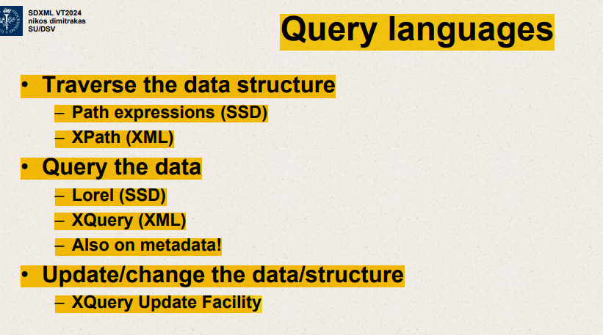

Traverse the data structure

Path expressions (SSD)

Xpath(XML)

Query languages

Query the data

Lorel (SSD)

Xquery – do conditions,construct output ,order result

Metadata and data are together in semi structured data.

Xquery update facility

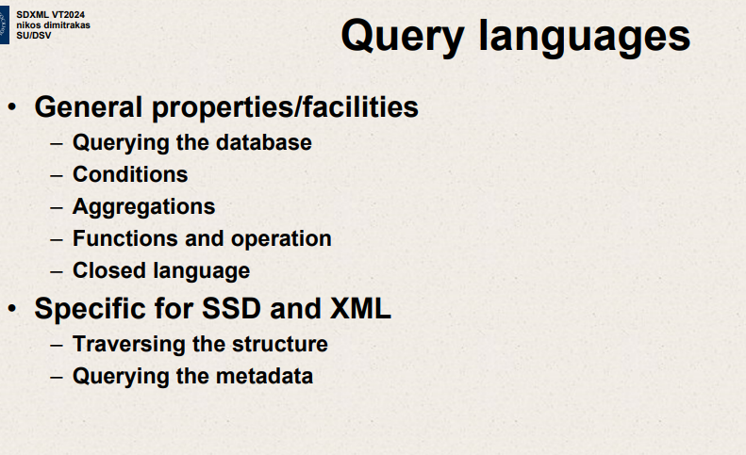

General properties/facilities – querying the DB

Conditions

Aggregations

Functions ,operation

Closed language – result of expression can be used as input for next expression

Specific for SSD and XML

Traversing structure

Querying metadata

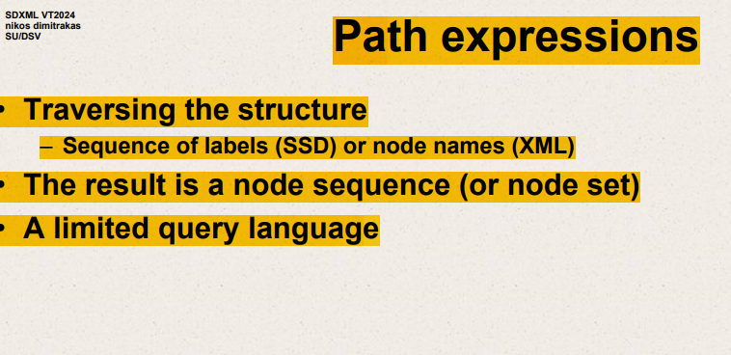

Traversing structure – way to go from one node to another node.

SSD’s – like labels then a node or value.

Like sequence of labels

Need language for traversing structure

Want to traverse the structure

Need to have a way to go from one node to another node.

Result – specify a path through the tree.

Path expressions

Traversing structure

* Sequence of labels(SSD) or node names(XML)

SSD path expressions

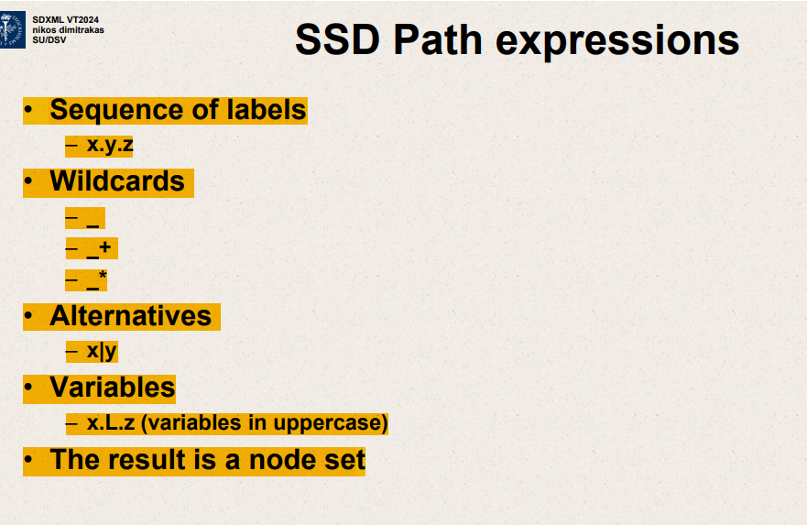

+ - one or more labels random

Vertical line – go either to x or to the y

Once traversed L label,

people.person.name.first

The image shows a diagram that is likely used to illustrate the concept of path expressions in a data structure, such as those found in XML or a similar markup language. Here's what the path expressions seem to indicate:

1. **people.person.name.first**: This path expression would access the first name of a person within a "people" element. According to the diagram, there are multiple "person" elements within "people", and each "person" has a "name" element with a "first" sub-element for the first name. For instance, it would retrieve "Carl" for the first person and "Mia" for the second person.
2. **people.person.(email|mobile)**: This expression uses a choice selection, indicating that you want to retrieve either the email or the mobile number of each person within the "people" collection.

This kind of expression might be used in a context where you want to retrieve contact information but are flexible about which type you receive.

1. **people.*.mobile**: The asterisk (**\***) is a wildcard that typically matches any element within the specified level. This expression is asking for the mobile numbers of all elements at the same level as "person" under "people". However, the diagram suggests that "mobile" is directly under "person", so the wildcard here may be redundant or incorrect unless there are other sibling elements to "person" that also contain a "mobile" sub-element.
2. **people._name**: The underscore (**_**) is not a standard character used in path expressions for XML or JSON. It could be a placeholder or a mistake in this context. If it were meant to be a standard path expression, it might incorrectly attempt to access an element "_name" directly under "people", which does not exist according to the diagram.

This kind of path expression syntax is often used to navigate hierarchically structured data, allowing the user to specify precisely which data items they want to extract.

Lorel

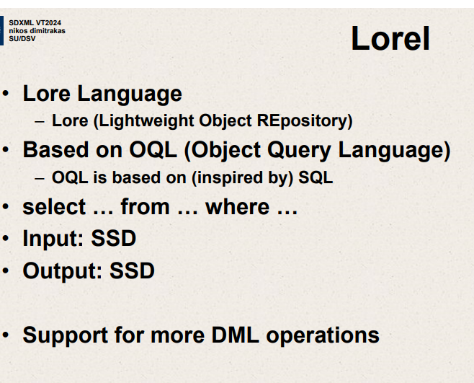

Lore language – Lightweight Object Repository

Lore

Lore was a database in a repository

SQL there in 80’s

Based on OQL – Object Query Language

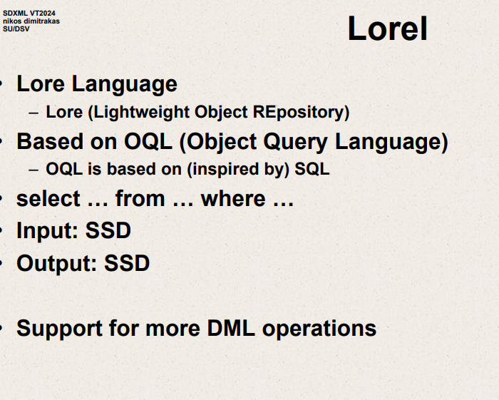

Lore – Lightweight object repository

Input SSD

Output also should be SSD

Won’t look at other DML operations

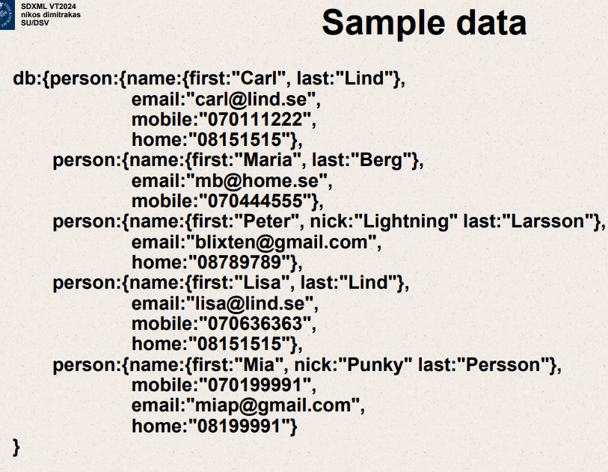

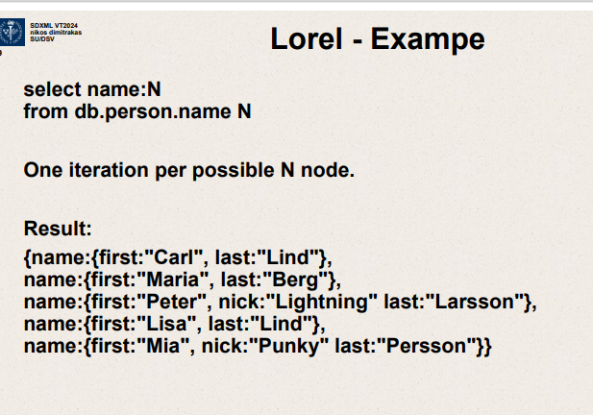

This example returns 5 nodes in a set.

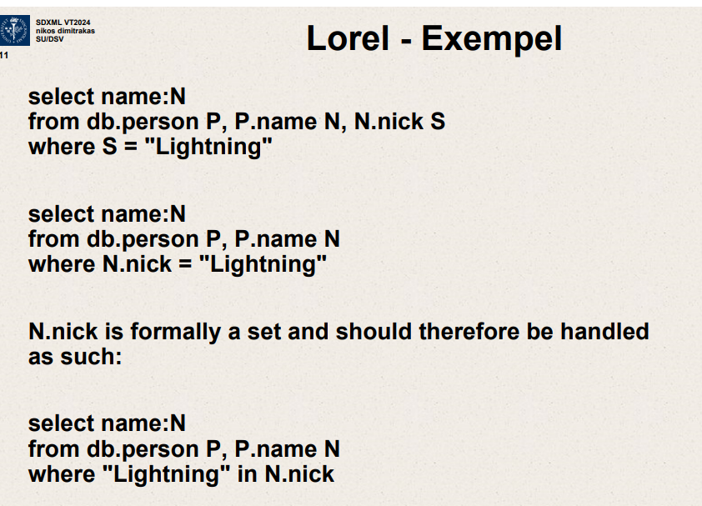

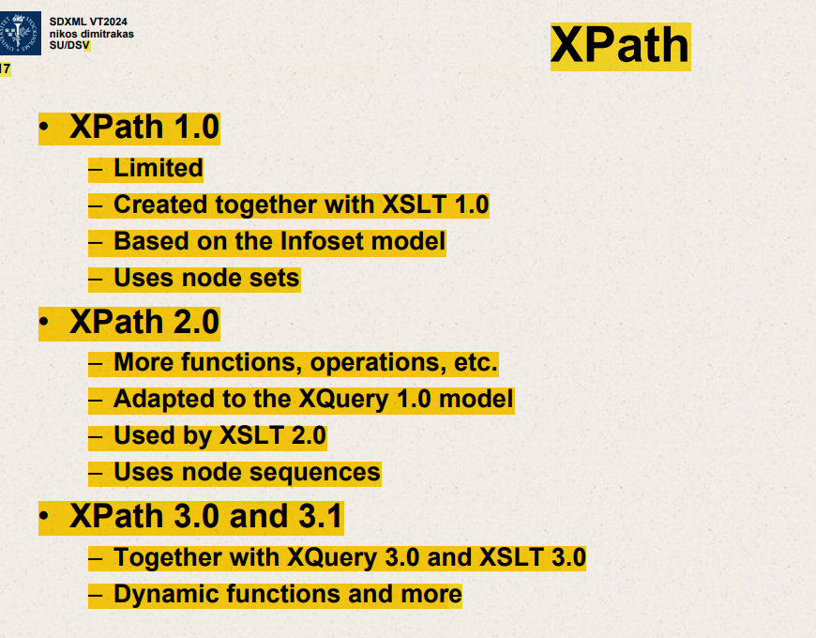

Xpath 1.0

Limited

Created together with XSLT 1.0

Uses node sets

Xpath 2.0

More functions, operations etc

Adapted to Xquery 1.0 model

Used by XSLT 2.0

Uses node sequences

Xpath 3.0 and 3.1

Together with Xquery 3.0 and XSLT

Dynamic functions and more

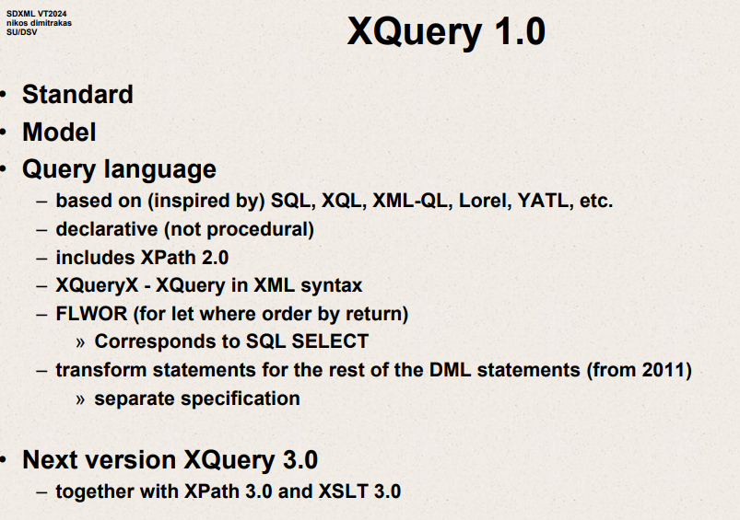

Standard

Model

Query Language

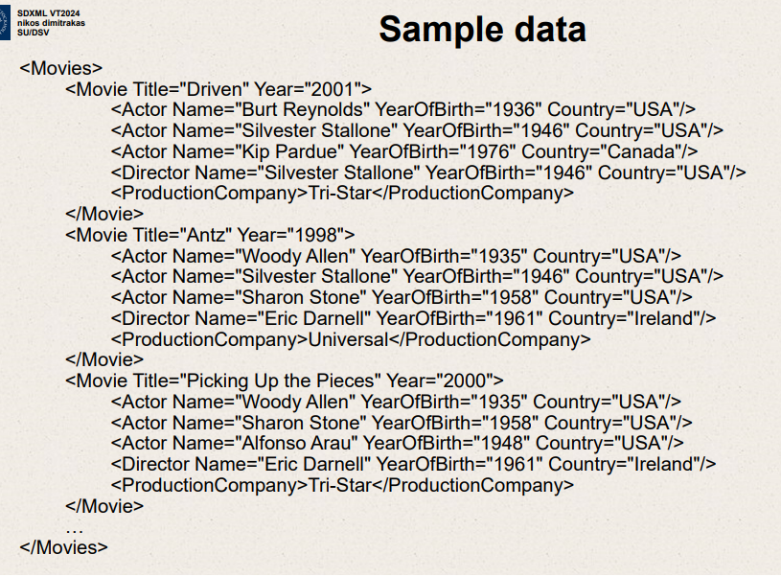

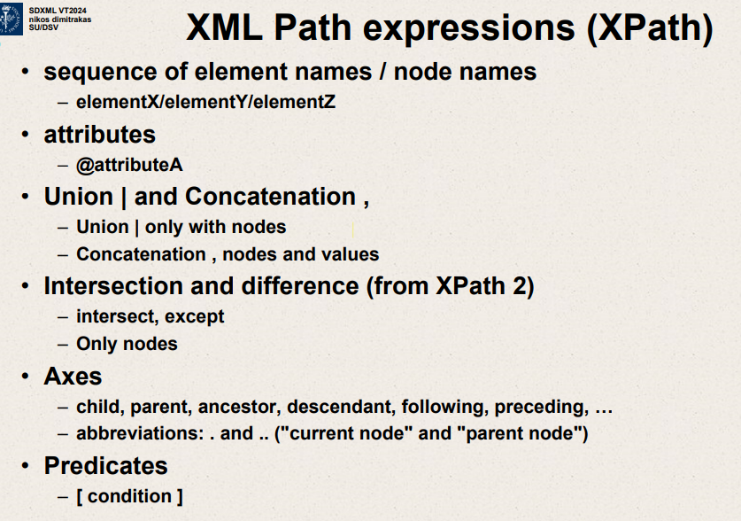

Sequence of element names / node names

elementX /elementY /elementZ

XML Path expressions (XPath)

attributes

@attributeA

Union| and Concatenation

Union | only with nodes

Concatenation , nodes and values

Intersection and difference (from XPath 2)

Intersect,except

Only nodes

Xpath

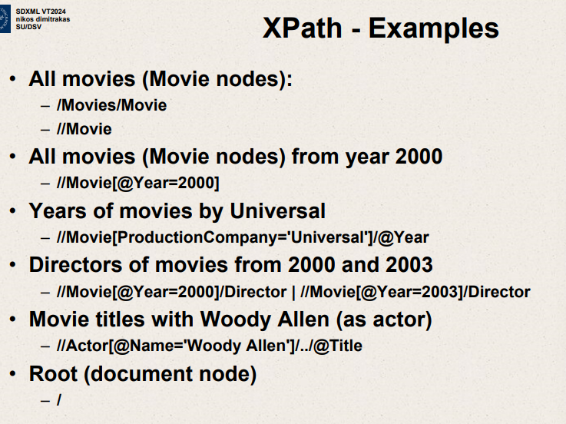

All movies (Movie nodes)

/Movies/Movie

//Movie

All movies (Movie nodes) from year 2000

//Movie[@Year=2000]

Years of movies by Universal

//Movie[ProductionCompany =’Universal’]/@Year

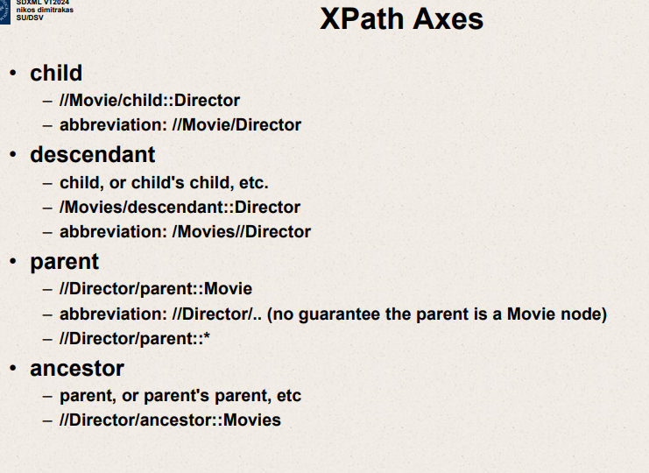

Name of axis :: element you want

child

-// Movie /child ::Director

//Movie/Director

For every movie find me the child that is called Director

Axis child is default axis always used

-abbreviation ://Movie/Director

descendant

child ,or child’s child etc

/Movies/descendant ::Director

Abbreviation :/Movies//Director

Double slash – as many steps as necessary to get to the Director without caring what steps skipped there in between

Parent

Go to the director which is deeper in the structure and then come back to the parent of director

Not only say go to parent ,we say go to a parent that needs to be Movie.

//Director/ parent : :Movie

Go to the parent of Director that is Movie

If we use abbreviation just go to parent without checking it is movie

// Director/ parent ::*

Ancestor

Parent or parent’s parent etc

// Director/ ancestor :: Movies

Go upwards as many steps as needed

Xpath Axes

attribute

// Movie / attribute :: Title

abbreviation://Movie/@Title

self

// Movie / self :: Movie

Abbreviation : //Movie/.

Descendant-or-self

//Movie/descendant-or-self ::Director

f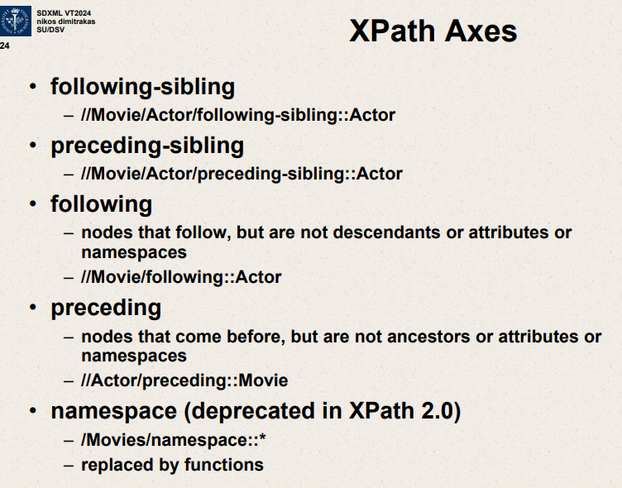

<A>

<B/>

<B/>

<C/>

<D/>

<B/>

</A>

<A>

<B/>

<B/>  
</A>

These 5 are siblings because they have same parent.

Following sibling and preceding sibling

following - sibling

// Movie/Actor/ following-sibling ::Actor

preceding-sibling

//Movie/Actor/preceding-sibling::Actor

following

nodes that follow but are not descendants or attributes of namespaces.

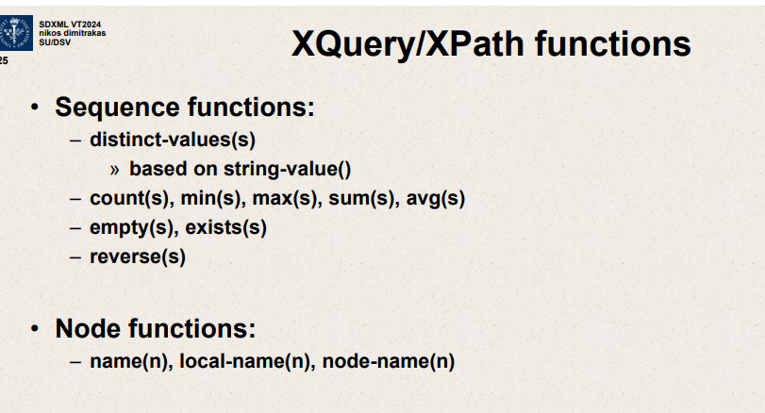

Sequence functions

Distinct - values(s)

based on string- value()

put numbers it will give minimum of numbers

put string it will give minimum of strings

Node functions:

Name(n),local-name(n) ,node-name(n)

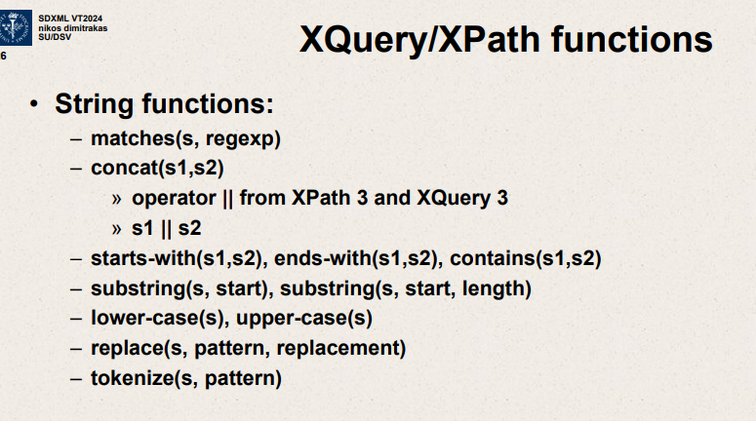

String functions

* matches(s,regexp)
* concat(s1,s2)
* operator || from Xpath 3 and Xquery 3
* s1||s2

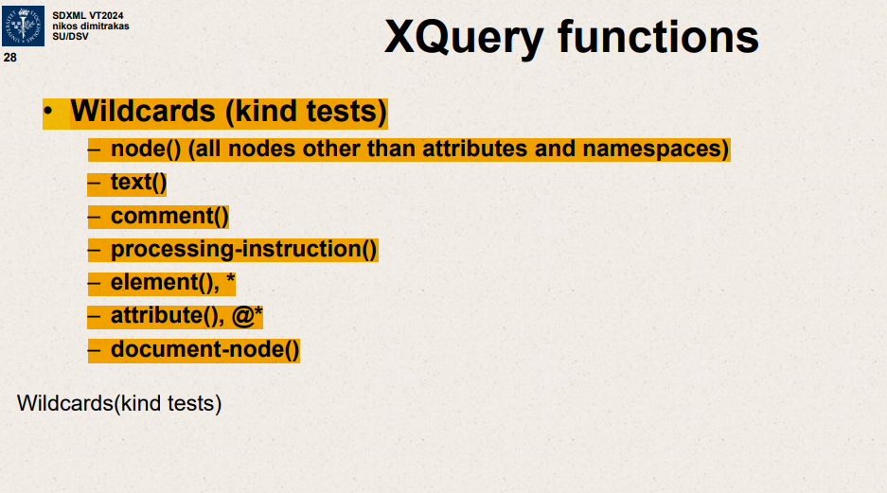

Elements, text nodes, comment nodes

-element(),*

document-node()

tokenize – split a string

Xquery/Xpath functions

Doc(URI)

Put(n,URI)

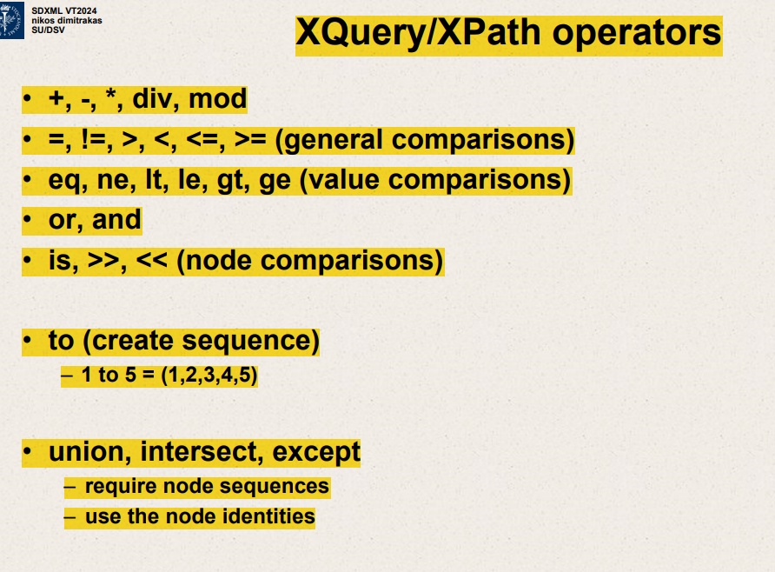

Mathematical operations

All comparison operators

1=1 ,1eq1

(1,2,3)= (2,5) ,atleast one of left sequence should be equal to one of right sequence

(1,2,3)> (2,5) correct as 3>2

to (create sequences)

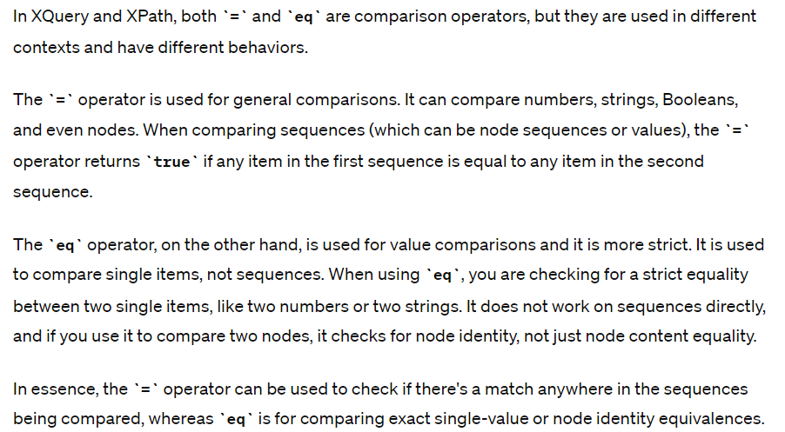

Eq is more strict ,used for comparing exact single value or node identity

It checks if node identity is the same

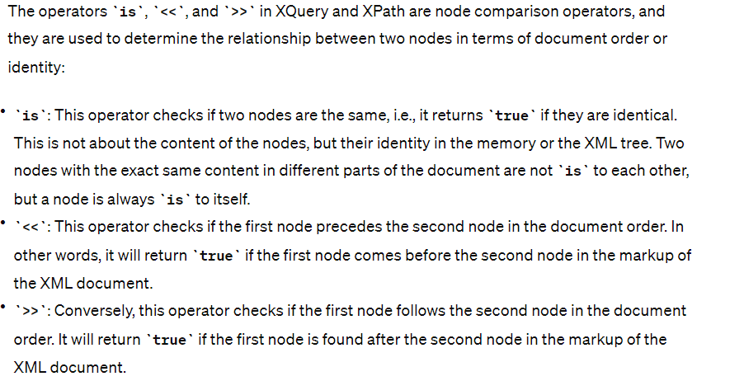

/ - Path operator

, (Comma operator ) and () (sequence construction)

(1,2,3,4)

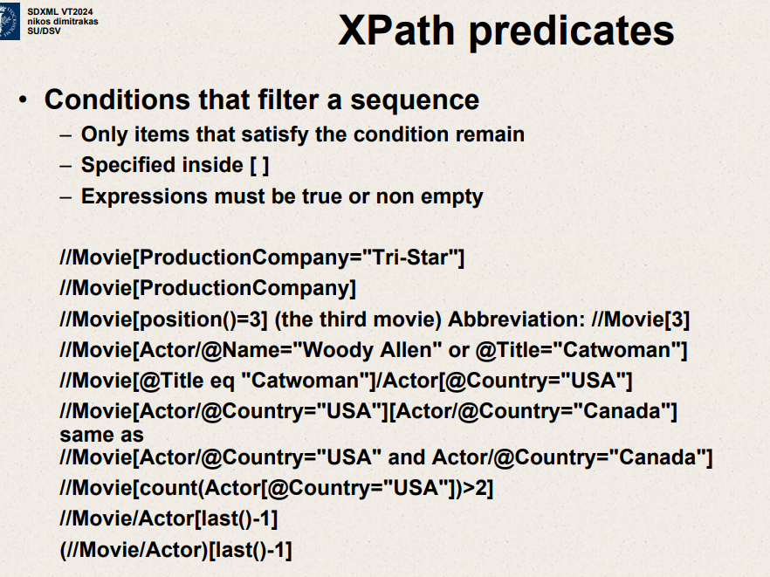

Conditions that filter a sequence

Only items that satisfy the condition remain

Specified inside []

Expressions must be true or non empty

//Movie[ProductionCompany=”Tri-star”]

Just needs to exist

Find any movie that has a ProductionCompany

// Movie[ProductionCompany]

//Movie[position()=3]

Find movie where number of actors from USA is greater than 2

//Movie[count(Actor[@Country=”USA”])>2]

The XPath expression **//Director/parent::Movie** retrieves the entire **<Movie>** element, including all its child elements and attributes, not just the director details. This means that for each **<Director>** tag found in the XML document, the whole movie record—encapsulating all data such as the movie's title, year, actors, director, and production company—is selected and displayed. This can be particularly useful when you need a comprehensive overview of the movies along with their associated director details in the context of the entire movie data structure.

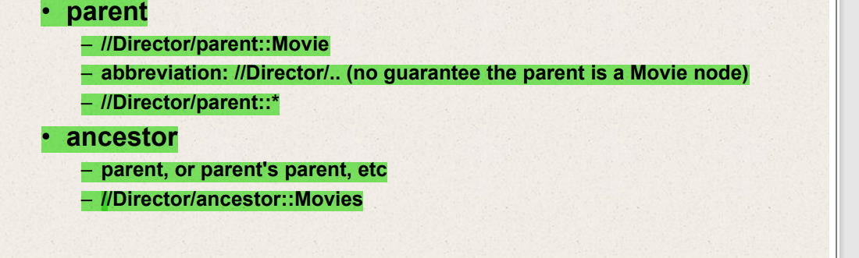Top of Form

2nd one retrieves Movies and everything inside the Movies tag.

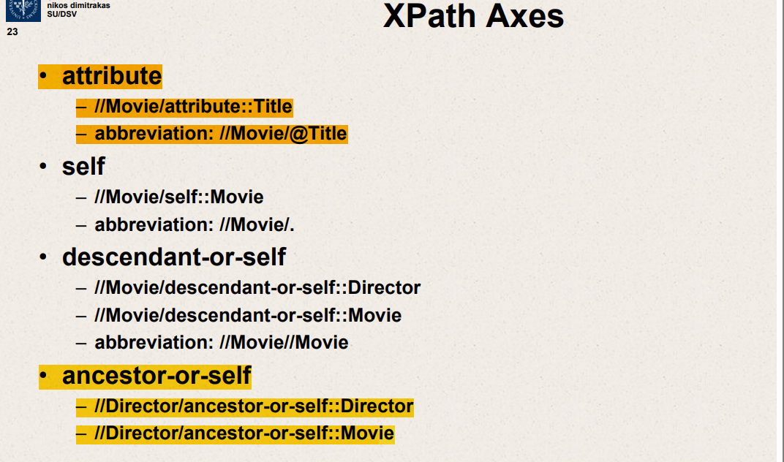

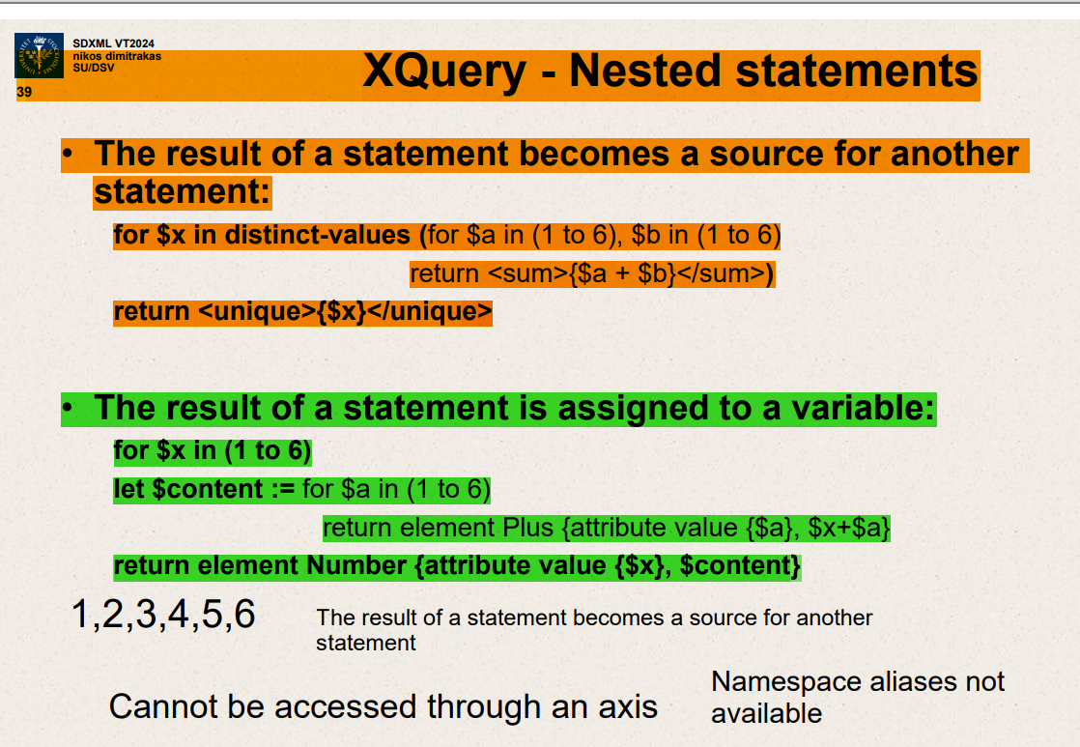

Xquery nested statements

Result of a statement becomes a source for another statement

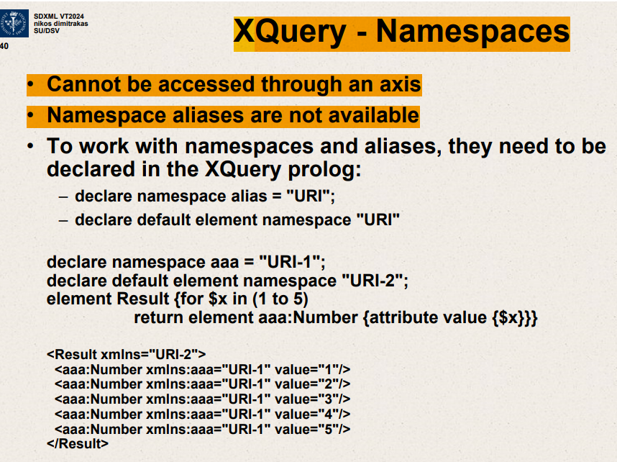

The slide you've shared is about handling namespaces in XQuerys. Let's break down the key points presented and how they apply to the example given:

**Key Points on the Slide:**

1. **Access through an Axis**: It states that namespaces cannot be accessed through an axis in XQuery, which means that you cannot traverse XML documents by referencing namespace prefixes directly in path expressions.
2. **Namespace Aliases**: The slide notes that namespace aliases are not available directly. To use namespaces effectively, they must be declared at the start of the XQuery script.
3. **Declaring Namespaces in XQuery**:
   * **Namespace Alias**: To work with namespaces, you need to declare a namespace alias. This involves assigning a prefix to a URI (Uniform Resource Identifier), which is a reference to a namespace.
   * **Default Element Namespace**: You can declare a default element namespace so that elements you create without a specific prefix will be automatically associated with this namespace.

**Example Explained:**

In the example on the slide, two namespace declarations are shown:

* **declare namespace aaa = "URI-1";** assigns the prefix **aaa** to "URI-1".
* **sdeclare default element namespace "URI-2";** sets "URI-2" as the default namespace for elements that don’t specify a prefix.

**XQuery Script:**

xquery

Copy code

declare namespace aaa = "URI-1"; declare default element namespace "URI-2"; element Result {for $x in (1 to 5) return element aaa:Number {attribute value {$x}}}

**Breakdown:**

* **Outer Element**: **element Result { ... }** creates an element **<Result>** that uses the default namespace "URI-2", which is why its opening tag is **<Result xmlns="URI-2">**.
* **Inner Element**: Inside the **Result** element, a loop iterates from 1 to 5. For each iteration, it creates an element **<aaa:Number>** with an attribute **value** set to the loop variable **$x**. Since **aaa:Number** explicitly uses the **aaa** prefix, it is associated with the "URI-1" namespace. Hence, each **<aaa:Number>** element is output with the namespace declaration **xmlns:aaa="URI-1"**.

**Output XML:**

xml

Copy code

<Result xmlns="URI-2"> <aaa:Number xmlns:aaa="URI-1" value="1"/> <aaa:Number xmlns:aaa="URI-1" value="2"/> <aaa:Number xmlns:aaa="URI-1" value="3"/> <aaa:Number xmlns:aaa="URI-1" value="4"/> <aaa:Number xmlns:aaa="URI-1" value="5"/> </Result>

This output correctly reflects the structure and namespaces as defined by the XQuery script in the example. Each **<aaa:Number>** element specifies its namespace to ensure it is understood correctly in contexts where multiple namespaces might be used.

Xquery prolog – functions, variables, namespaces, collation, sorting etc

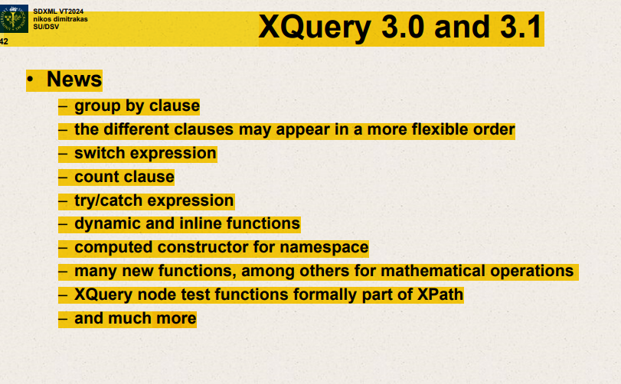

Group by clause

Different clauses may appear in a more flexible order

Switch expression

Count clause

Try/catch expresssion

Dynamic and inline functions

Computed constructor for namespace

Many new functions among others for mathematical operations

Group by – return clause executed once per group

for $x in 1 to 5

let $even :=($x mod 2)=0

group by $even

return element Numbers { attribute even {$even},$x}

Iteration variables become sequences

Switch

For $x in 0 to 3

Return element { switch($x)

case 0 return “Zero”

case 1 return “One”

default return “Many” }

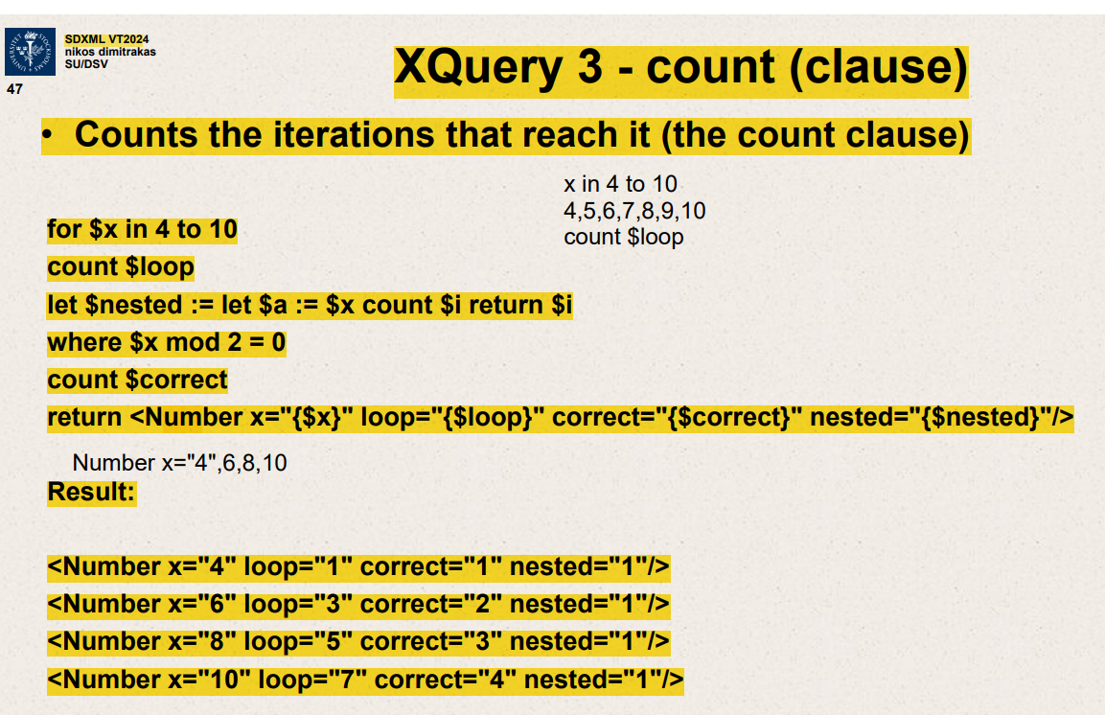

Count(clause)

The slide you've provided is about using the **count** clause in XQuery 3 to keep track of iterations in a **for** loop and apply it in nested expressions. Let's break down the query piece by piece:

1. s**For Loop**:
   * **for $x in 4 to 10**: This loop iterates over the numbers from 4 to 10, assigning each number in turn to the variable **$x**.
2. **Count Loop**:
   * **count $loop**: This clause is used to count each iteration of the loop over **$x**. The variable **$loop** keeps track of the iteration number for each **$x**.
3. **Nested Count**:
   * **let $nested := let $a := $x count $i return $i**: Inside the main loop, there is a nested **let** expression that also uses a **count** clause. Here, **$a** is set to the value of **$x**, and **$i** counts the iterations of this inner **let** expression. Since this **let** is not actually a loop and is executed only once per iteration of the outer loop, **$i** will always be 1.
4. **Condition**:
   * **where $x mod 2 = 0**: This condition filters the values of **$x** to include only even numbers. So, the **return** statement and any associated counting or processing only apply to **$x** values that are even.
5. **Correct Count**:
   * **count $correct**: This counts the iterations of the loop that pass the **where** filter. In other words, it counts how many times the loop has encountered an even number up to the current point.
6. **Return Statement**:
   * **return <Number x="{$x}" loop="{$loop}" correct="{$correct}" nested="{$nested}"/>**: For each even number from 4 to 10, this returns an XML element showing the current value of **$x**, the total loop count for **$x**, the count of even numbers up to that point (**$correct**), and the count from the nested **let** (which is always 1).

**Example Output Analysis**

* For **$x = 4**:
  + **loop** = 1 (first iteration)
  + **correct** = 1 (first even number)
  + **nested** = 1 (nested count)
* For **$x = 6**:
  + **loop** = 3 (third iteration)
  + **correct** = 2 (second even number)
  + **nested** = 1
* For **$x = 8**:
  + **loop** = 5 (fifth iteration)
  + **correct** = 3 (third even number)
  + **nested** = 1
* For **$x = 10**:
  + **loop** = 7 (seventh iteration)
  + **correct** = 4 (fourth even number)
  + **nested** = 1

This query demonstrates the use of the **count** clause to track iterations and conditional passes within an XQuery for loop, particularly useful in debugging or when specific counting metrics are needed for each iteration.

Top of Form

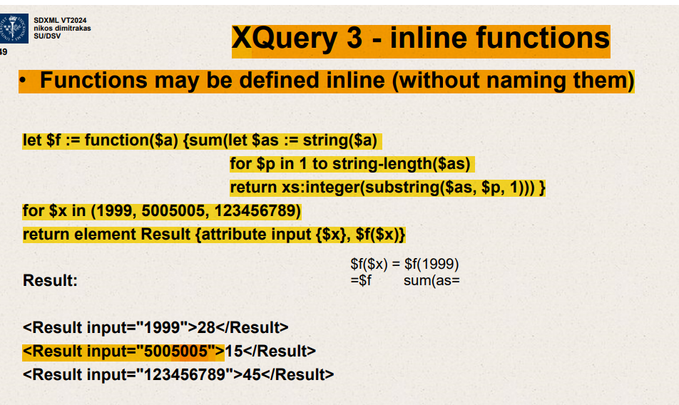

Functions may be defined inline

Let $f:=function($a)s

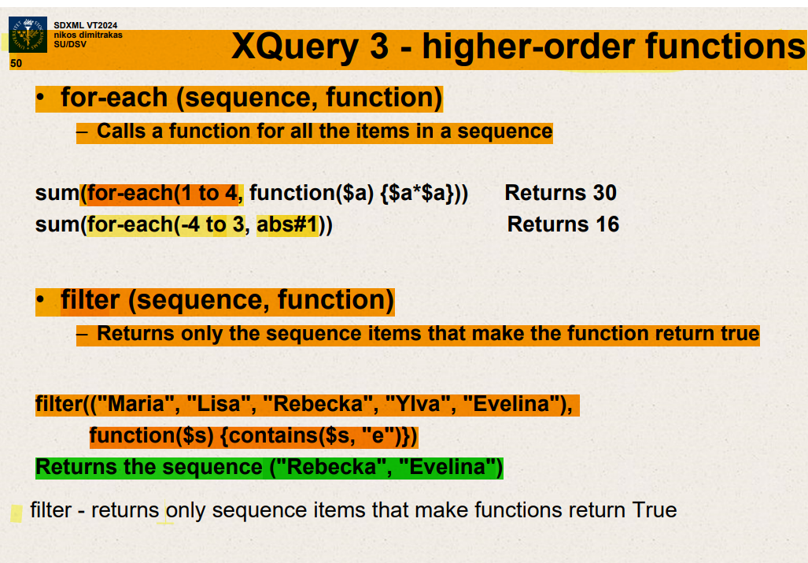

for-each (sequence,function)

Calls a function for all items in a sequence.

for-each(1 to 4,function($a){$a*$a})

{1,4,9,16}

Filter(sequence,function) – returns all items that make function return True.

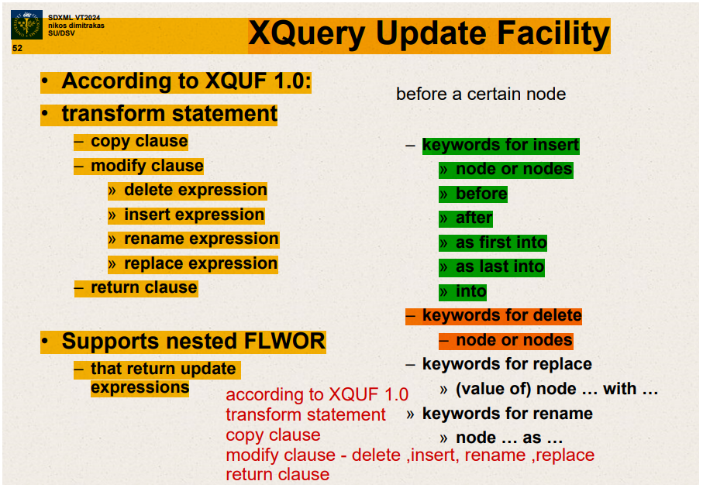

Transform statement

Copy clause

Modify clause

* delete
* insert
* rename
* replace
* return clause

return clause

Supports nested FLWOR that return update expressions

Xquery transform

copy – create copy of XML document

modify – one or more expressions that update the copy (insert,delete,rename,replace)

return – usually the copy ,but node reconstruction possible

copy $x:= <root><a>456</a><a>789</a></root>

Xquery – transform- replace

